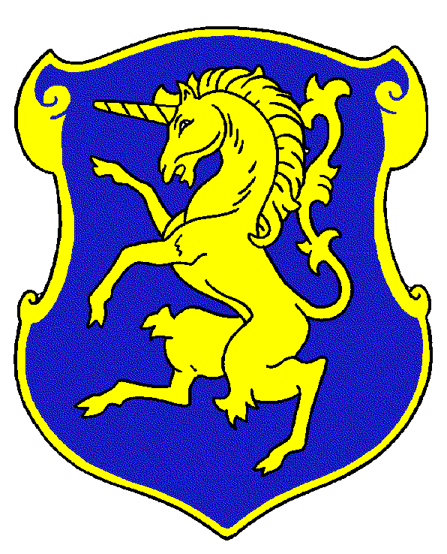

Join the Charge to support the 6th Cavalry Museum!

Membership at the 6th Cavalry Museum plays a vital role in supporting the Museum. Member dues are used to meet administrative and operational expenses as well as to provide the opportunity to develop new exhibits, acquire historic artifacts, provide educational experiences and create living history programs.

Your annual membership entitles you to unlimited free admission for two to the museum when you present your membership card and two free admissions to “Remembering Our Heroes” event. What a value for just $25 per year.

Name__________________________________________E-mail__________________________
Address________________________________________________________________________
City/ST/Zip_____________________________________Phone___________________________Make check payable to: 6th Cavalry Museum – Mail to: PO Box 2011 Fort Oglethorpe, GA 30742

